**APPENDICES**

**__________________________________________________________________**

**APPENDIX A**

**__________________________________________________________________**

**Schematic Diagram and PCB Layout**

**Appendix A.1 Schematic**

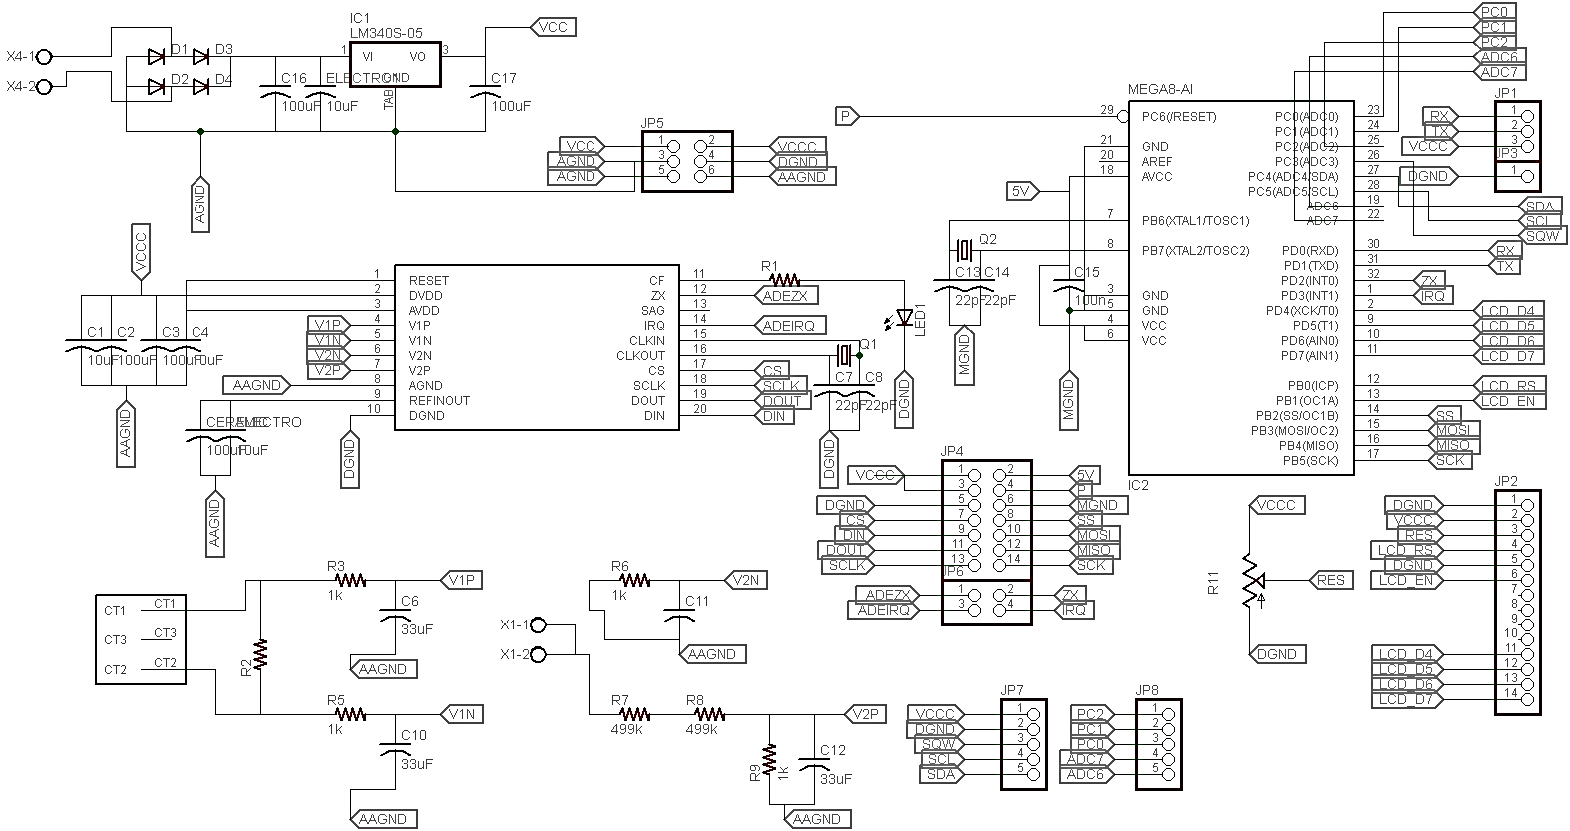

**Appendix A.2 Double Sided PCB Layout**

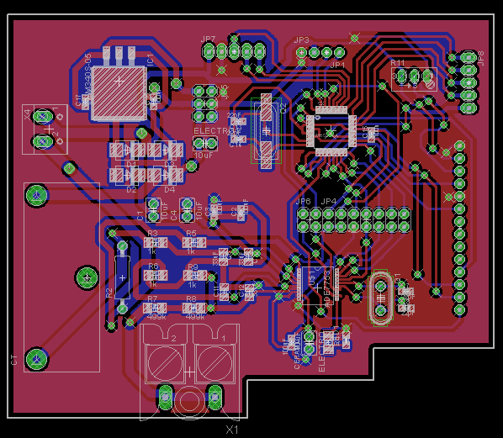

**Appendix A.3 Top Side of the PCB**

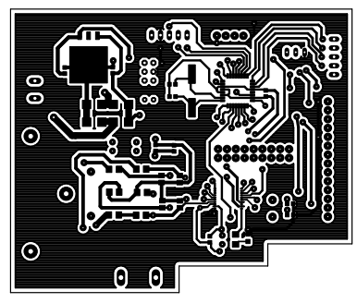

**Appendix A.4 Bottom Side of the PCB**

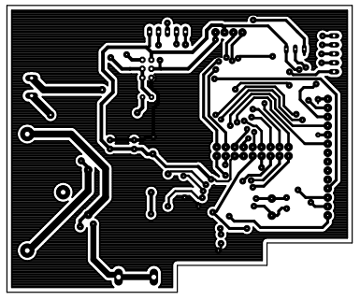

**APPENDIX B**

**__________________________________________________________________**

**Snapshots of IDEs Used In This Study**

**B.1 Atmel Studio**

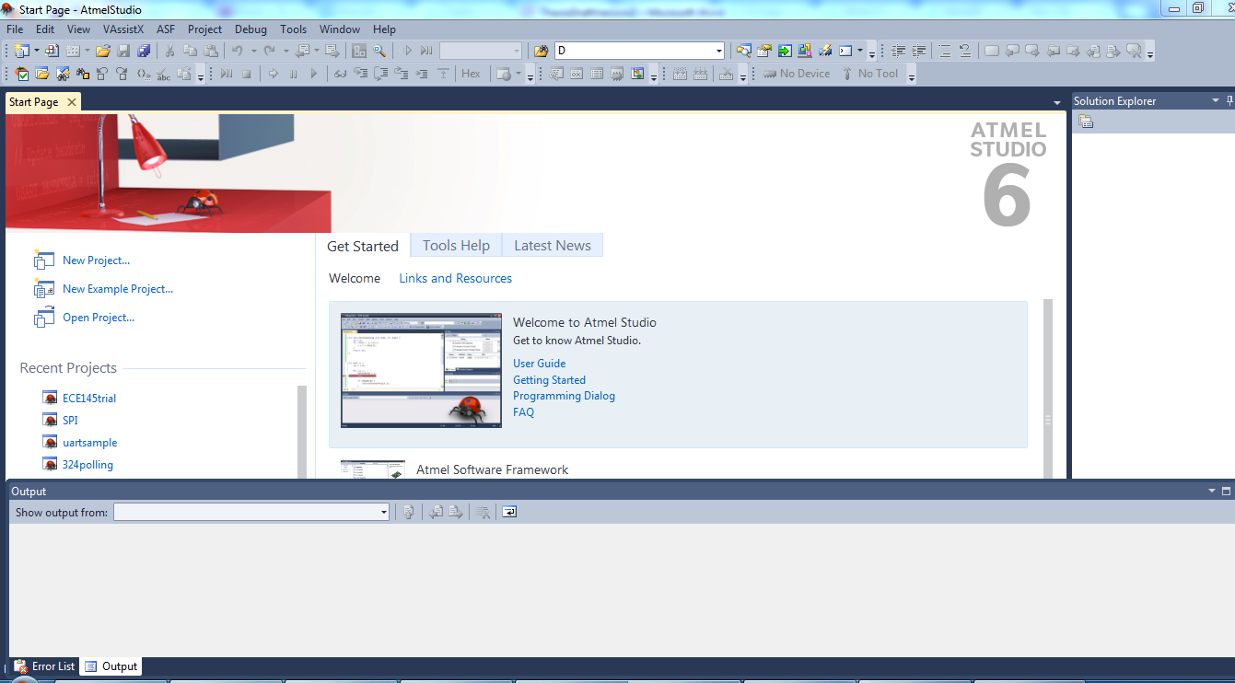

**B.2 Arduino IDE**

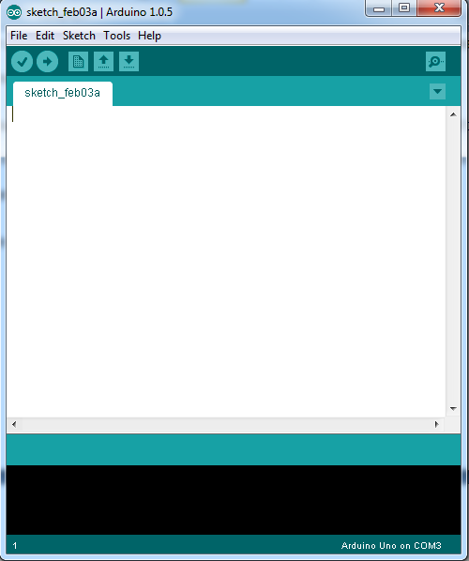

**B.3 EagleCad**

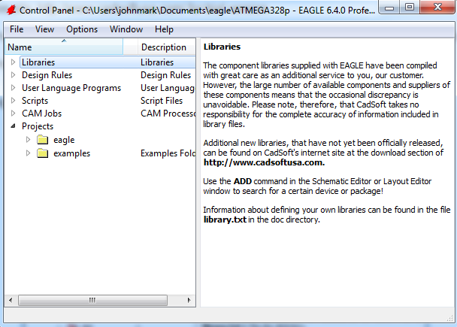

**APPENDIX C**

**__________________________________________________________________**

**Arduino UNO Board**

**C.1 Arduino Board Pin Assignments**

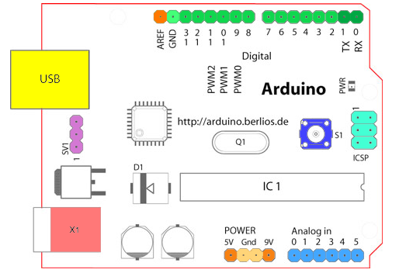

**APPENDIX D**

**__________________________________________________________________**

**Pin Configurations and Theory of Operation of Components**

**D.1 ADE7753**

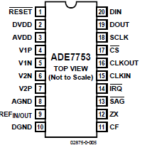

**D.2 Analog Gain Register – ADE7753**

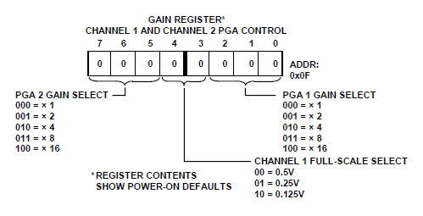

**D.3 PGA –ADE7753**

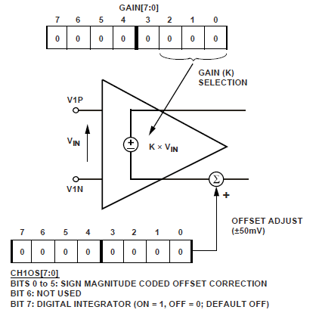

**D.4 Maximum Signal – ADE7753**

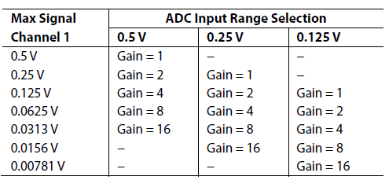

**D.5 ADC –ADE7753**

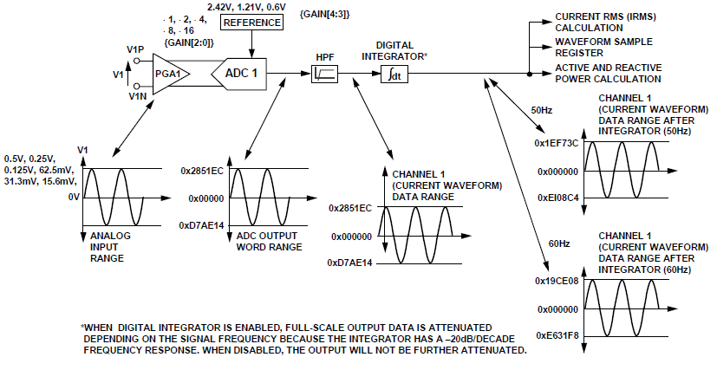

**D.6 RMS Signal Processing – ADE7753**

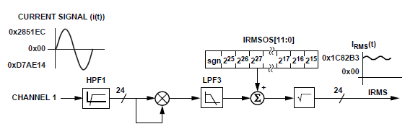

**D.7 Settling Time –ADE7753**

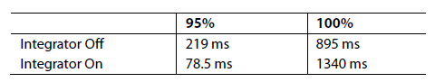

Settling Time for the IRMS Measurement

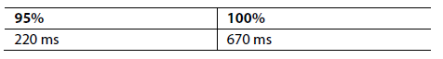

Settling Time for the VRMS Measurement

**D.8 ADC in Channel 2 –ADE7753**

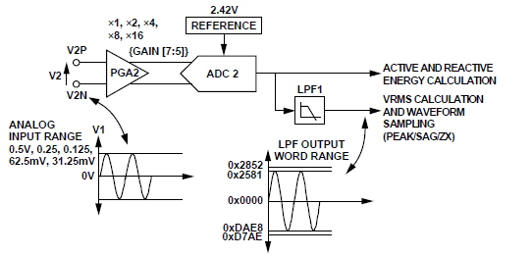

**D.9 Channel 2 RMS Processing – ADE7753**

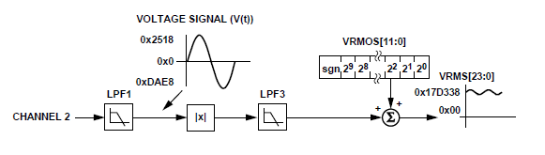

**D.10 Xbee Pro Pin Configurations**

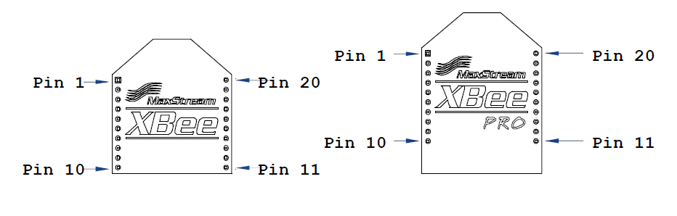

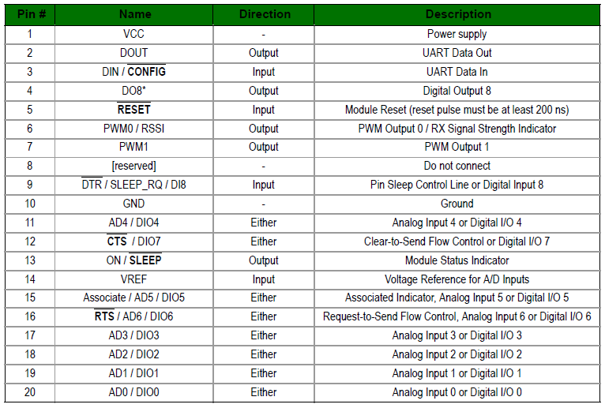

**D.11** Character LCD type pin diagram and pin configurations

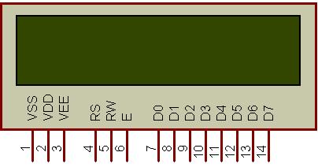

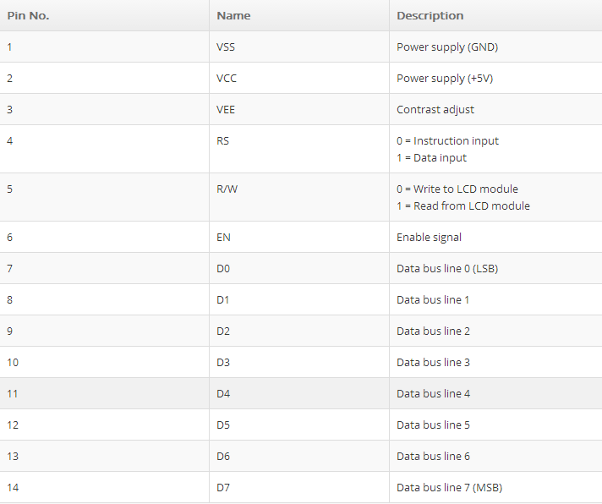

**D.12 AC1150 Current Transformer and Schematic Diagram**

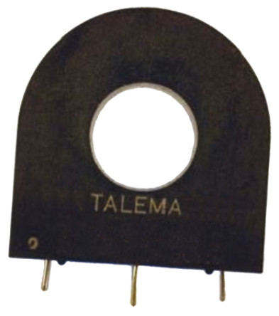

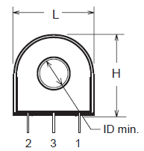

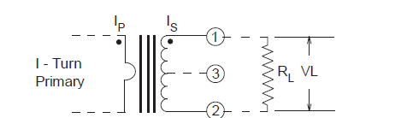

**D.13 TQFP (Thin Quad Flat Package) Pin Assignments of ATMEGA328p**

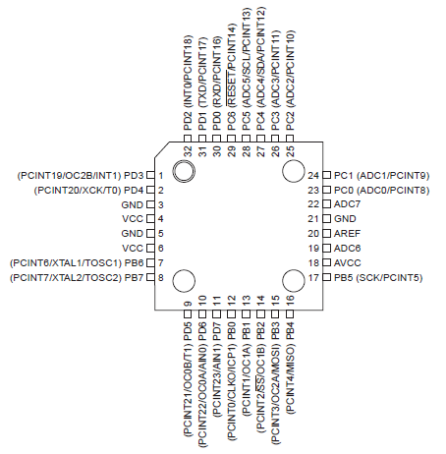

**APPENDIX E**

**__________________________________________________________________**

**Master-Slave Relationship**

**E.1 SPI Connection from Master to Slave**

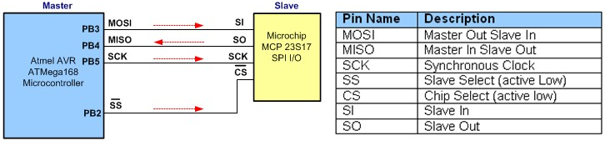

Typical SPI Master and SPI Slave Device Connection

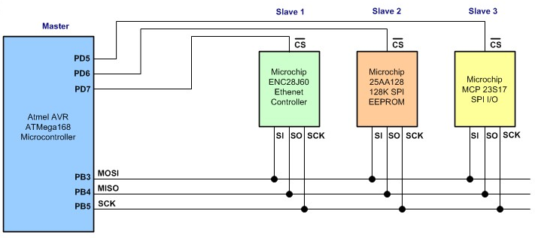

Typical SPI Master and Multiple SPI Slave Device Connection

**E.2 SPI Transfer Diagram**

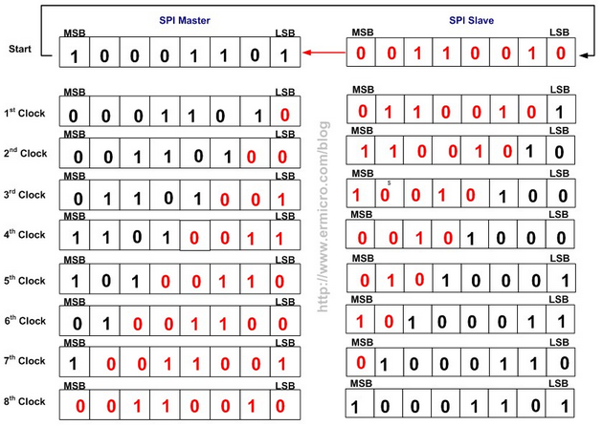

**APPENDIX F**

**__________________________________________________________________**

**Apparatus Used**

**F.1 CA8220 Power Analyzer**

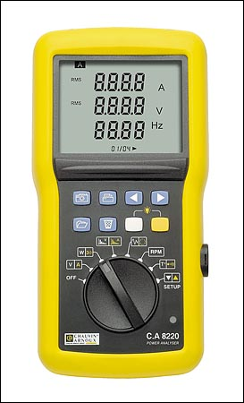

**APPENDIX G**

**__________________________________________________________________**

**Software Development**

**Appendix G.1 Billing Options**

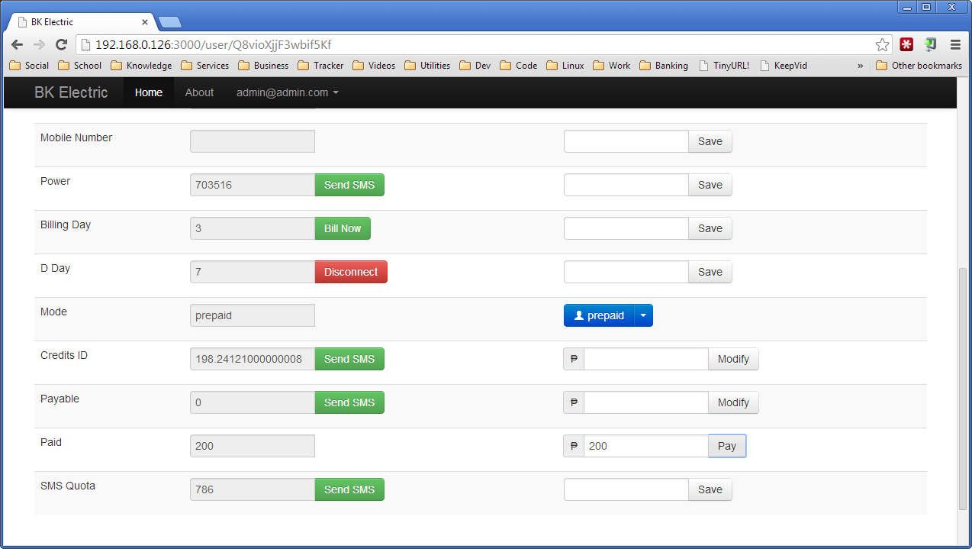

**Appendix G.2 User Options**

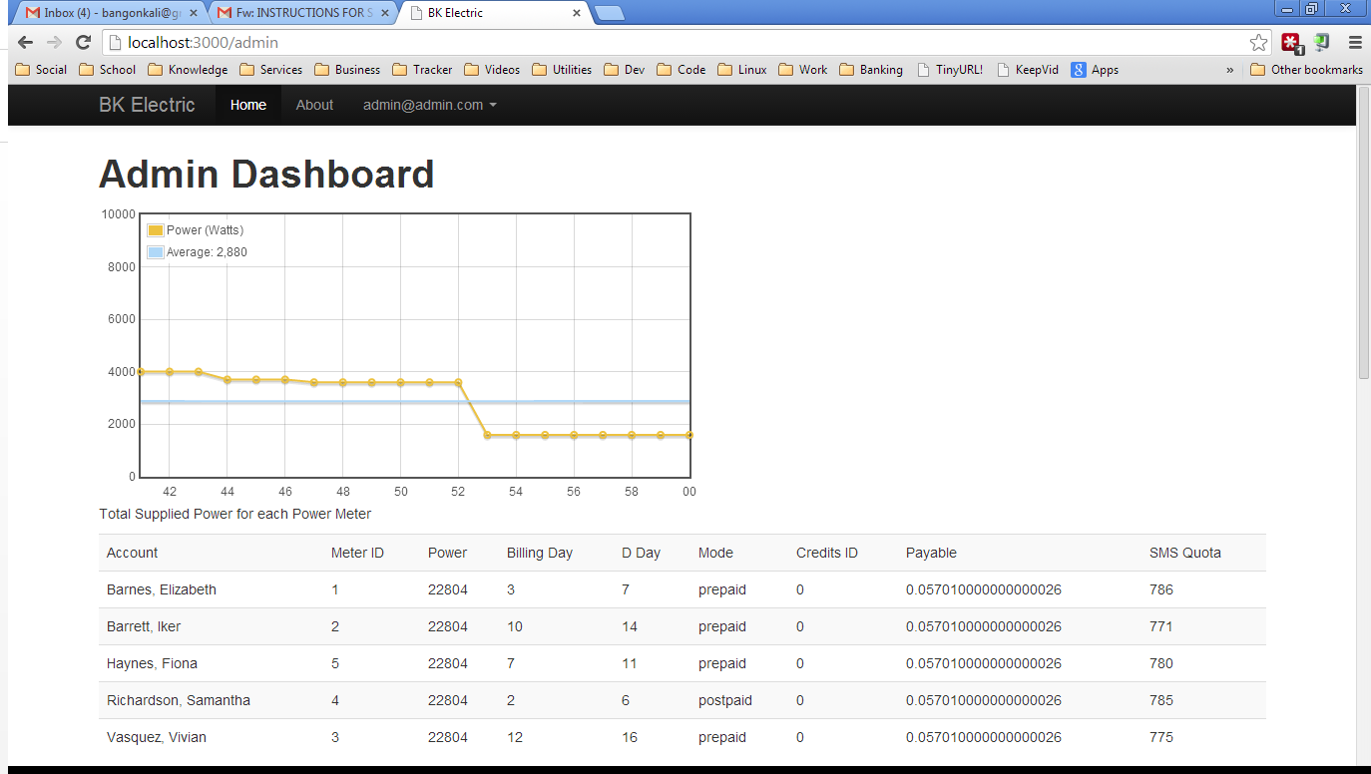

**APPENDIX H**

**__________________________________________________________________**

**Source Codes, Datasheet and Demo Videos (Inside the Compact Disc)**